How to Access Math “BIG IDEAS” Assignments

- Log into Student Portal and click on Schoology.

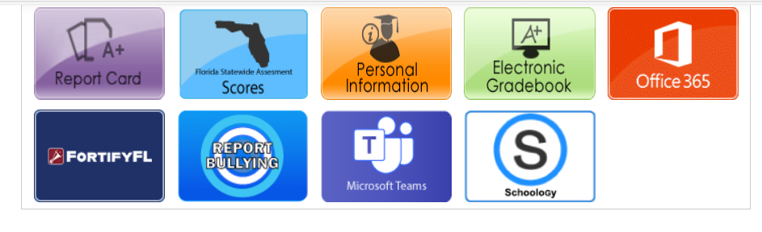

- Click on Math Course.

- Click on Big Ideas Math.
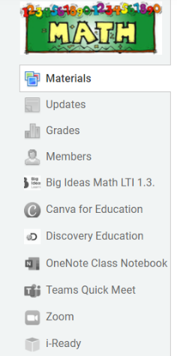

- Click on the “Go” button.
